| **MINISTRY OF EDUCATION AND TRAINING**  **EASTERN INTERNATIONAL UNIVERSITY**  https://lh3.googleusercontent.com/0XKqRuHRwfZKX_OYfschHKg1FksSVj3KzeQO-STCeGeO1ZVX2a3Ggnac51EaROqEnFih27njU3yMmwpMLwsz0F4jUHZTAQT_Sl6uoNcbH1k7FnP5yj3RFsFCBsLusnSxiG62Uh64  **MIS 451**  **MACHINE LEARNING FOR BUSINESS**  **Group Final Project**  **Classification: Default of Credit Card Clients**  **Lecturer:** Mr. Dang Thai Doan and Ms. Huynh Gia Linh  Prepared by: **4 Pieces team**   | **Full Name** | **IRN** | | --- | --- | | Nguyễn Thanh Giang | 2132300593 | | Bùi Gia Tuệ | 2132300511 | | Bùi Thị Thanh Thảo | 2232300157 | | Trần Tiến Thảo Hiếu Ngân | 2032300513 |   **Quarter 3/2024-2025** |
| --- | --- | --- | --- | --- | --- | --- | --- | --- | --- | --- |

**TABLE OF CONTENTS**

**EXECUTIVE SUMMARY 2**

**1. INTRODUCTION 2**

**2. DATASET OVERVIEW 2**

**3. EXPLORATORY DATA ANALYSIS (EDA) 2**

Table 1: Structure and properties of the dataset 3

Figure 1: Count of default vs non-default clients 3

Figure 2: Gender Distribution 4

Figure 3: Education Levels 4

Figure 4: Marital Status 5

Figure 5: Heatmap correlation with target variables 6

**4. DATA CLEANING AND TRANSFORMATION 6**

Figure 6: Handle invalid categorical values 6

Figure 7: One-hot encode categorical features 6

Figure 8: Aggregate total payments and bills 7

Figure 9: Select Features 7

Figure 10: Train/Test Split 8

Figure 11: Applying SMOTE for training set 8

**5. MODEL DEVELOPMENT 8**

a. Logistic Regression 9

Figure 12: Logistic Regression Classification Report 9

b. Random Forest 9

Figure 13: Random Forest Classification Report 9

c. Support Vector Machine (SVM) 10

Figure 14: Support Vector Machine (SVM) Classification Report 10

d. MLP Neural Network 10

Figure 15: MLP Neural Network Classification Report 10

Figure 16: Summary metrics 11

**6. INTERPRETATION AND INSIGHTS 11**

**7. REFERENCES 12**

# 

# EXECUTIVE SUMMARY

This project aims to predict credit card defaults using the UCI "Default of Credit Card Clients" dataset. By applying both traditional machine learning and deep learning models, we seek to identify key factors influencing default risk.

The dataset comprises 30,000 records with 23 features, including demographic information, payment history, and billing details. Our analysis will assist financial institutions in making informed decisions regarding credit risk assessment.

# 1. INTRODUCTION

Credit card default poses significant challenges to financial institutions, impacting profitability and risk management. Predicting potential defaulters enables proactive measures to mitigate losses.

In this study, we utilize the UCI "Default of Credit Card Clients" dataset to develop predictive models that classify clients based on their likelihood of defaulting. By analyzing various attributes such as age, education, and payment history, we aim to uncover patterns that distinguish defaulters from non-defaulters.

# 2. DATASET OVERVIEW

The dataset, sourced from the UCI Machine Learning Repository, contains information on 30,000 credit card clients in Taiwan from April to September 2005. It includes 23 features:

* **Demographic Factors**: Gender, education level, marital status, and age.
* **Financial Data**: Credit limit, bill statements, and previous payments over six months.
* **Payment History**: Repayment status for each month from April to September 2005.

The target variable is a binary indicator of default payment in the next month (1 = default, 0 = no default). This dataset provides a comprehensive view of client behaviors and financial standings, making it suitable for classification tasks in credit risk modeling.

# 3. EXPLORATORY DATA ANALYSIS (EDA)

In this section, we explored the dataset to understand its structure, detect any missing or duplicate values, and examine the distribution of key features. These initial steps are essential to guide our data cleaning and modeling process.

To summarize the structure and properties of the dataset, we provide the following table:

### Table 1: Structure and properties of the dataset

| **Aspect** | **Description** |
| --- | --- |
| Number of records | 30 |
| Number of attributes | 23 features + 1 target |
| Target variable | default payment next month (binary: 0 = no default, 1 = default) |
| Data types | Mostly numerical (integer and float); includes categorical numerical fields |
| Missing values | None detected |
| Duplicate entries | None detected |
| Class distribution | ~77% non-default (0), ~23% default (1) |

We also used visualizations to analyze the target variable.

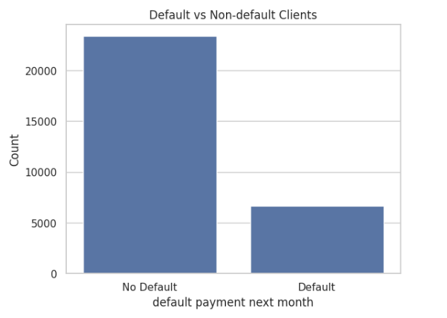

### Figure 1: Count of default vs non-default clients

The distribution showed a significant class imbalance, which will need to be addressed in the preprocessing phase to avoid biased model learning.

### 

### Figure 2: Gender Distribution

The dataset contains more female clients than male clients. Male (1) accounts for about 60% and female (2) is 40%.

### 

### Figure 3: Education Levels

The most common level is university (label 2), followed by graduate school (1) and high school (3). The existence of codes like 0, 5, and 6 indicates input errors or undefined categories, which justifies our recoding in the part data transformation.

### 

### Figure 4: Marital Status

The majority of clients are married (1), followed by single (2). The presence of code 3 again signals the need for recoding into "others" (in data transformation part).

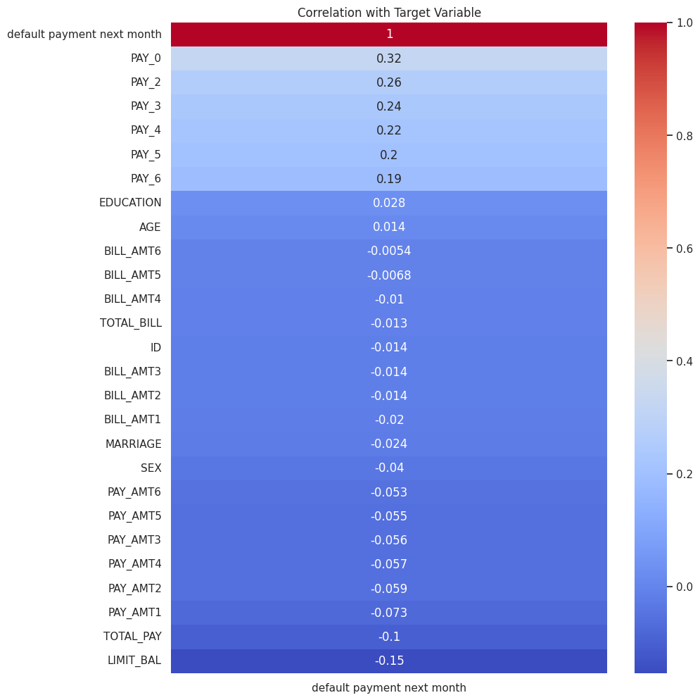

### Figure 5: Heatmap correlation with target variables

To better understand which features are most related to default, we calculated the correlation between each variable and the target. The result shows that recent repayment status variables (especially **PAY_0** (0.32), **PAY_2** (0.26), and **PAY_3** (0.24)) have the strongest positive correlation with default, suggesting that recent delays in payments are strong signals of risk.

On the other hand, features like credit limit (**LIMIT_BAL** (-0.15)**)** and total payment (**TOTAL_PAY** (-0.1)**)** show negative correlations, meaning customers with higher limits or payments tend to default less. Demographic variables such as gender, age, and education have very weak correlations and may not significantly affect predictions on their own.

From these analyses, we gained several key insights. First, the target variable is imbalanced, with fewer default cases. Second, some features may contain inconsistent or rare categorical values, which require cleaning. Third, the repayment history features appear to be among the most informative and will be crucial in model training.

# 4. DATA CLEANING AND TRANSFORMATION

Before training our classification models, we performed several data cleaning and transformation steps to ensure the dataset was properly formatted, balanced, and ready for modeling. These steps included handling unusual values, encoding categorical variables, engineering new features, and balancing the dataset.

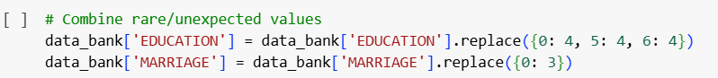

### Figure 6: Handle invalid categorical values

We began by examining the categorical variables for any unexpected or invalid values. For instance, the **EDUCATION** and **MARRIAGE** columns included codes such as 0, 5, and 6, which were not properly defined. We grouped these rare categories into a single new category labeled as “others” to avoid introducing noise into the model.



### Figure 7: One-hot encode categorical features

Next, we applied **One-Hot Encoding** to convert categorical variables (such as education, gender, and marital status) into numerical format. This step created separate binary columns for each category, allowing the models to process these features effectively.



### Figure 8: Aggregate total payments and bills

To improve feature quality, we engineered two new variables:

1. **TOTAL_BILL_AMT**: the total bill amount across six months (sum of **BILL_AMT1** to **BILL_AMT6**)
2. **TOTAL_PAY_AMT**: the total payment amount across the same period (sum of **PAY_AMT1** to **PAY_AMT6**)

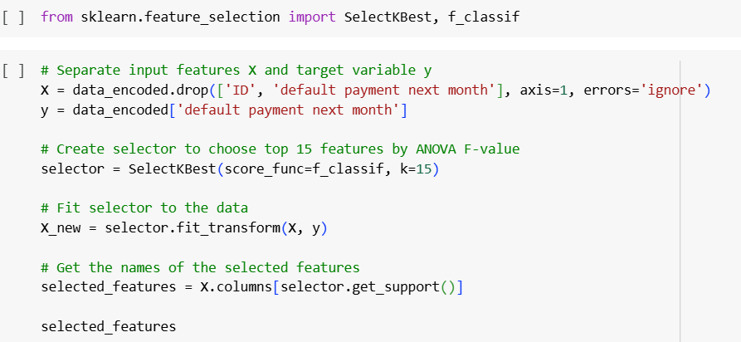

### Figure 9: Select Features

Afterward, we selected important features using **SelectKBest** with the ANOVA F-test (**f_classif**) method. This step helped reduce dimensionality and retained the most relevant features for predicting default.

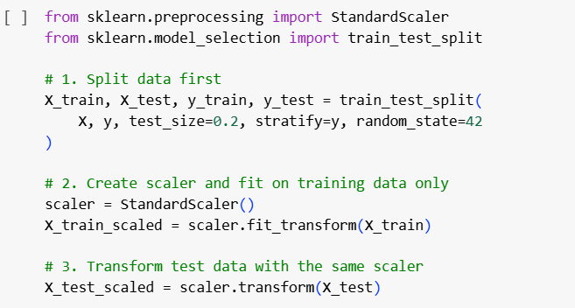

### Figure 10: Train/Test Split

We then split the dataset into training and testing subsets, ensuring that the distribution of the target variable was preserved in both sets.

To make the features comparable in scale, especially for algorithms like SVM and deep learning, we applied **StandardScaler** to standardize the input features. This transformed the data so that each feature had a mean of 0 and a standard deviation of 1.

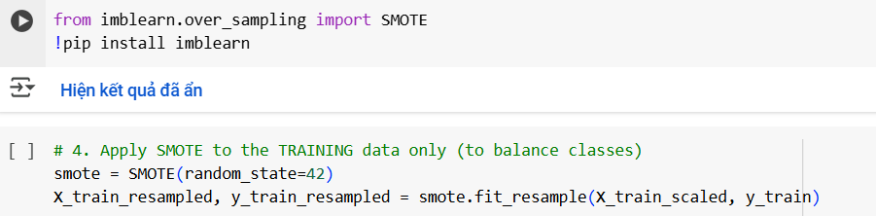

### Figure 11: Applying SMOTE for training set

Lastly, we addressed the class imbalance in the training set using **SMOTE (Synthetic Minority Over-sampling Technique)**. This technique created synthetic examples of the minority class (defaults) to balance the class distribution, allowing the models to learn more effectively from both classes.

These preprocessing steps helped improve the data quality, reduce bias, and prepare the dataset for accurate and fair model training.

# 5. MODEL DEVELOPMENT

## Logistic Regression

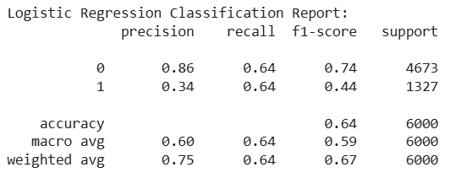

### Figure 12: Logistic Regression Classification Report

We selected logistic regression as a baseline model because it is simple, fast, and interpretable. It is commonly used in binary classification problems like default prediction, especially when we want to understand the influence of each feature.

The model achieved an accuracy of **64%**. It performed well on non-default cases (precision: **0.86**, recall: **0.64**), but struggled with default cases (precision: **0.34**, F1-score: **0.44**). This indicates that while the model can detect many defaulters, it also produces many false alarms.

## Random Forest

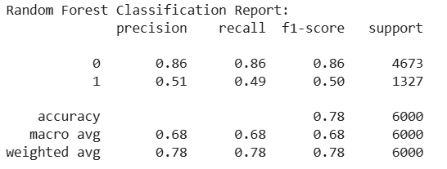

### Figure 13: Random Forest Classification Report

We chose random forest because it is robust to noise, handles feature interactions well, and often outperforms simpler models in classification tasks. It also helps reduce overfitting by using an ensemble of decision trees.

The model reached an accuracy of **78%**. It maintained strong performance on non-defaults (F1-score: **0.86**) and improved on defaults compared to logistic regression, with better precision (**0.51**) and a balanced F1-score of **0.50**. This makes it a more reliable model for identifying high-risk clients.

## Support Vector Machine (SVM)

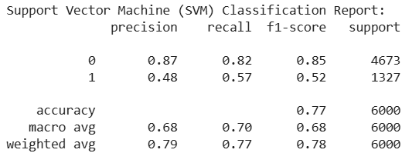

### Figure 14: Support Vector Machine (SVM) Classification Report

We selected SVM with an RBF kernel because it is effective in high-dimensional spaces and can model complex non-linear decision boundaries. It is also less prone to overfitting in cases with many features.

The model reached an accuracy of **77%**. It performed well on non-defaults (F1-score: **0.85**) and better than logistic regression on defaults, with a precision of **0.48** and an F1-score of **0.52**. This shows a balanced ability to detect defaulters without too many false positives.

## MLP Neural Network

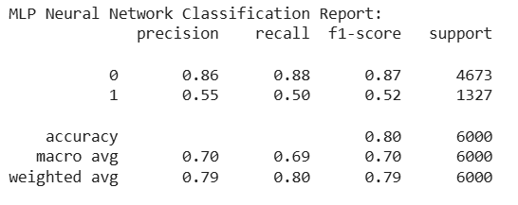

### Figure 15: MLP Neural Network Classification Report

We applied a Multi-layer Perceptron (MLP) using Keras to test a deep learning approach. MLP is powerful at capturing complex patterns in data, especially after scaling and resampling.

This model gave the highest accuracy so far at **80%**. It performed strongly on non-defaults (F1-score: **0.87**) and achieved an F1-score of **0.52** for defaults, similar to SVM. The overall macro average (F1: **0.70**) suggests balanced performance across both classes.

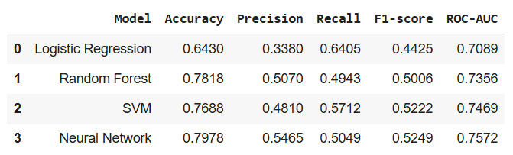

### Figure 16: Summary metrics

To further evaluate model performance, we considered the ROC-AUC (Receiver Operating Characteristic – Area Under the Curve) score. This metric measures a model’s ability to distinguish between the two classes - in our case, default and non-default clients. A ROC-AUC score of 1.0 indicates perfect separation, while a score of 0.5 means the model performs no better than random guessing.

Among the models we tested, the Neural Network achieved the highest ROC-AUC score of **0.7572**, followed closely by the SVM (**0.7469**) and Random Forest (**0.7356**). The Logistic Regression model had the lowest ROC-AUC of **0.7089**, although still above the acceptable threshold of 0.7. These results suggest that while all models demonstrated a decent ability to separate the classes, the Neural Network was the most effective at identifying patterns that differentiate defaulters from non-defaulters.

# 6. INTERPRETATION AND INSIGHTS

From our model evaluation results, several meaningful insights emerged that could inform real-world business decisions.

First, the most influential features in predicting default were recent repayment behaviors, particularly the **PAY_0**, **PAY_2**, and **PAY_3** variables. These indicate that clients who recently missed or delayed payments are significantly more likely to default in the following month. This supports the idea that **payment patterns over the most recent months are strong early warning signals** of financial risk.

Second, models that captured non-linear relationships and feature interactions—such as **Random Forest, SVM, and MLP Neural Network**—performed better than the simpler **Logistic Regression**. Among them, the **Neural Network achieved the best ROC-AUC score (0.7572)** and the most balanced classification performance, suggesting it is the most reliable model for identifying defaulters.

Third, demographic features like gender, age, education, and marital status showed only weak correlations with default behavior. This implies that while such features may provide additional context, they are **not strong predictors on their own**. Financial behavior and payment history remain the most critical factors.

From a business standpoint, these findings suggest that **monitoring recent repayment status and payment activity can significantly improve early risk detection**. Institutions can use such models to prioritize follow-up with at-risk clients, offer financial counseling, or adjust credit policies proactively.

# 7. REFERENCES

*UCI Machine Learning Repository*. (n.d.). https://archive.ics.uci.edu/dataset/350/default+of+credit+card+clients